Name: | ___________________________________________________ | Date: ___________
 | Year 10 Mathematics – Mini Algebra test  Test 6, 2021  Topic – Algebra | 27  = %
Weighting | 5% of Total Grade | 30 minutes
Question 1 (9 marks)
Solve the following:

- $3x+2=11$

- $2\left(x+8\right)=4x+8$

- $\frac{4x}{3}+\frac{3}{4}=-\frac{x}{6}$

Question 2 (2 marks)
On the number line below place these two inequalities

- $x>4$

- $5≥x$

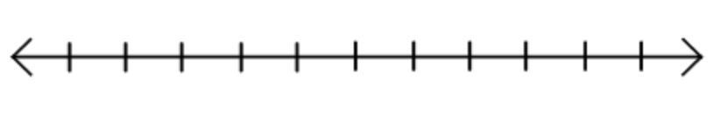

Question 3 (5 marks)
Solve for the following inequalities

- $2x+9≥21$

- $-2(x+4)≤14$

Question 4 (6 marks)
Kerry wants to get her plumbing fixed and wants to pay less than $350 she has two choices
Plumber A charges a $35 on call plus an extra $25 per hour afterwards
Plumber B charges $40 on call plus an extra $20 per hour afterwards

- Write an equation for each scenario

- Solve for each equation

Question 5 (5 marks)
Find the equation of the line that is

- Parallel to $y=-x+6$and passes through $(2, 4)$

- Perpendicular to $y=\frac{3}{4}x+9$ and passes though (-2, 4)

